New Questions
ID 2060 Page 57
- Check if TRS is the right interpretation- think so

ID 2131 Page 16
- Said annual when recordings were done monthly for 10-20 years
- Gave half points

ID 2187 Page 87
- Watersource names were given as irrigation, discharge, and groundwater well
- Gave full points because only other option would be every single well owner name on the table
- Made up units for table continuation- gave a zero

ID 2188 Page 63
- LLM recognized TRS format below, gave full points

ID 2188 Page 105 and 95 and 41 and ID 2187 Page 92 ID 2060 Page 79
- LLM did not recognize what I believe is a TRS, pictured below
- ChatGPT said it is not the most common/standard TRS format, so I gave full points.

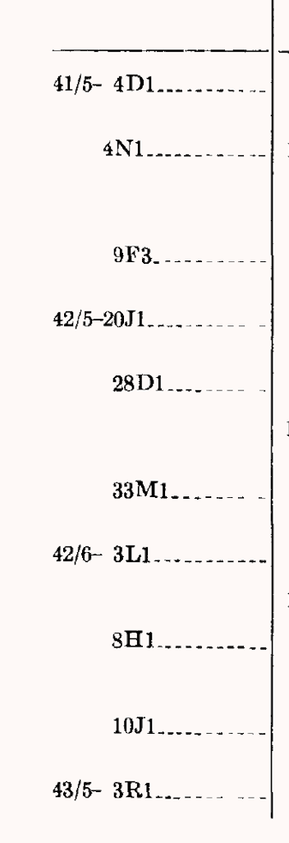

ID 38998 Page 26
- Row was logged without any information- every row is blank
- No analysis given, should I analyze it regularly, give a zero, or keep without a score?

ID 52651 Page 27
- Only county, lat/long, and TRS as location identifiers
- No info on location column, gave a 1
- Name of spring was often scrambled, gave a 0.5
- No dates of recording or temporal resolution- gave a zero
  - Dates of observations available and were one time recordings
- County written on page, only classified for half of the columns- gave a zero to empty columns

Resolved Questions
General Question
- When there are a lot of rows for a page, the LLM often meshes a lot of the rows together Don’t really know how to grade because if I follow our protocol, it should be correct since it’s on the page, but it feels wrong to give it full points because it’s clearly wrong
- Ex. ID 3153 Page 120 table separated by counties with watersource under its designated county. However, the LLM assigned watersources to the wrong county
- EX. ID 3153 Page 120- The LLM assigns the location from one row to another. It’s technically on the page so what do we do from there?

ID 2888 Page 394 and 392
- Date of recording filled out of “1908-1910”
- But no temporal resolution output
- Gave a 1 because doesn’t give specific times of collection, is that correct? ✅

ID 3153 Page 120
- 8 rows for sections of the table
- All said a county but none of them matched- gave zeros✅

IDs 53419 and 52651
- Used TRS and lat long to describe location
- No other location info except for county
- Still gave a zero because I believe county would be the most suitable to describe location❌
  - Grade because TRS or lat/long is acceptable

